Grade | Content Areas Being Integrated
4 | Visual Arts, History-Social Science, Common Core ELA

 | Arts Discipline | Other Content Area
Standards  Addressed in the Integrated Lesson/Activity | Visual and Performing Arts: Visual Arts 3.2 Identify and discuss the content of works of art in the past and present, focusing on the different cultures that have contributed to California’s history and art heritage. | History-Social Science 4.3 Students explain the economic, social, and political life in California from the establishment of the Bear Flag Republic through the Mexican- American War, the Gold Rush, and the granting of statehood.  CCSS/ELA Speaking & Listening # 1 Engage effectively in a range of collaborative discussions with diverse partners on grade 4 topics and texts, building on others’ ideas and expressing their own clearly.
Student Objectives in Each Discipline | By using the questioning technique of Visual Thinking Strategies, students will analyze and discuss artworks from the historical period of the California Gold Rush. Students will use vocabulary from both the elements of art and principles of art during their discussions. | Through the use of primary sources (paintings and photographs) students will deepen their understanding of life in California during the Gold Rush era.

Integrated Student Objective | What is the objective of the integrated activity? Look at connections being made between the two content areas.  Using paintings and photographs from the mid 1800’s as a departure point, students will examine the primary sources to build knowledge of life in California for various groups of people who moved there to seek their fortunes during the Gold Rush. Work will be discussion based in both small groups and whole class.
Essential Question | What is the question you want the students to be able to answer at the end of this lesson?  Can you use specific, historically accurate details to describe life for a specific group of people living in California during the Gold Rush?

Materials/Resources
Electronic and hard copies of various paintings and photographs such as:

The Lone Prospector, 1853 - A.D.O Browere (1814 - 1887)

Miners at Spanish Flats, El Dorado County (anonymous photograph)
Miners: A Moment at Rest (Gold Rush Camp), 1882 - Erneste E. Narjot
Miners in the Sierra, 1851 Charles Christian Nahl (1818-1878) and August Wenderoth (1819-1894)

A Lucky Striker, n.d., Artist Unknown

All images above available through the website for the Gene Autry Museum of Western Heritage (several images attached at the end of the lesson ...)

Chart paper

Lesson/Activity Description
- Have students discuss with desk partner what they have learned so far about life in California during the Gold Rush era.
- Show class The Lone Prospector, 1853 - A.D.O Browere
- Using VTS ask students the following questions: What is going on in this picture? What do you see that makes you say that? What more can you find?
- As students make observations we will chart the historical details we are learning, noting that experiences will be different for different groups of people coming to California.
- Divide students into groups of 4 - 5 and give each group a different image to analyze and chart.
- Students work with their group for 10 - 15 minutes.
- Each group shares their image and findings with the class and adds their historical details to class chart.
- Individual journaling (8 - 10 minutes). Students respond to the essential question: Can you use specific, historically accurate details to describe life for a specific group of people living in California during the Gold Rush?
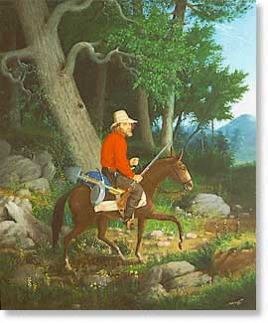

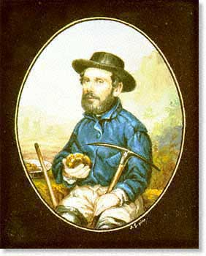
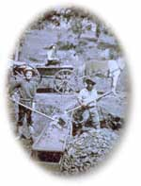
The Lone Prospector, 1853 - A.D.O Browere (1814 - 1887)
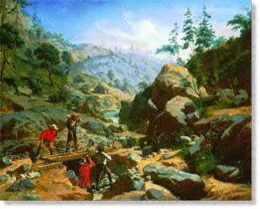
Charles Christian Nahl (1818-1878) and August Wenderoth (1819-1894), Miners in the Sierra, 1851

